**Epilogue**

We have reached a point that would usually count as the finish line for a story: the happy ending.

It is time to go back for a final visit with WealthGrid, where they have been working through exactly the transformation design that we explored in [Chapter 11](https://learning.oreilly.com/library/view/cloud-native-transformation/9781492048893/ch11.html#applying_the_patterns) and [Chapter 12](https://learning.oreilly.com/library/view/cloud-native-transformation/9781492048893/ch12.html#applying_the_patterns_a_cloud_native). The third time was the charm in terms of migration attempts: By applying the correct patterns in the proper order at the right times, the company was able to complete the first phase of the full transformation process. A transformation is not truly done until any remaining monoliths are re-architectured, a gradual process that will probably take another year or two to accomplish. The truly major milestone that WealthGrid has achieved, however, is that they’ve gained the ability, understanding, and awareness to do this as a natural course of business. The company is confident that they can continue to evolve; meanwhile, they can clearly see the results, and rewards, of all the progress they’ve made.

WealthGrid’s senior executives took a great deal more care to be involved with creating strategy for this third attempt, but to their credit they also recognized when it was time to get out of the way and let the middle managers and engineers take over executing the transition details. Jenny, the program manager who had catalyzed the company to go cloud native in the first place, was named Transformation Champion in recognition of her initiative and the knowledge she and her team had gained through their first two attempts. Both these efforts failed, and in very different ways, but were valuable learning experiences nonetheless.

Jenny led the Core Team and helped choose its members. They were able to work off to one side in creative mode to find a transformation path that *would* work for WealthGrid, while the rest of the company’s engineers focused on proficiently delivering features on the existing platform to keep customer value high in the meantime. Within three months, the Core Team was able to uncover the best approach for a new cloud native system through Exploratory Experiments and PoCs. At that point, a Platform Team was formed by splitting off several Core Team members; they were joined by a few more engineers who had shown particular ability during the organization’s failed “Let’s let everyone build a platform and see what happens!” over-investment in creativity during the first part of attempt number 2.

The Platform Team delivered a solid production-ready cloud native platform in under six months. Meanwhile, Jenny and the remaining Core Team members focused on developing some simple microservices applications both to test the new platform and create processes around developing on it. The Core Team was also preparing to onboard the remaining teams. They created excellent Dev Starter Pack materials, trainings, and Demo Apps while evangelizing the soon-to-come system across the organization, building excitement and buy-in. When the platform was ready, the development teams were incrementally onboarded onto the new system. Very quickly, WealthGrid was delivering new features and functionality for its products working entirely on the new cloud native platform (and using a newly evolved cloud-optimized delivery approach).

The entire company has gradually evolved to be working in the cloud native way: Build-Run Teams doing CI/CD and other cloud native methods to rapidly develop new features and deliver quick, incremental improvements—which the business teams are delighted to be included in planning. CEO Steve and the executive teams have embraced Dynamic Strategy. Throughout the entire organization there is a focus on delivery, but now there is also continued and meaningful investment in ongoing innovation. Even some pure research into emerging new technologies—Jenny has been named Designated Strategist and is now directing research, as well as shepherding innovation through all areas of the company. Everything is working well, and everyone is feeling confident. Once any remaining “Lift and Shift at the End” monoliths have been re-architected it will be time to shut down the old data centers for good. WealthGrid is well on its way to being a fully cloud native company.

**What’s Next?**

The next steps for WealthGrid are the same next steps for any company completing a cloud native transformation: keeping the balance between proficiency and creativity that current conditions dictate. The entire story of WealthGrid’s transformation journey can be shown as this fluctuating balance, graphed in [Figure E-1](https://learning.oreilly.com/library/view/cloud-native-transformation/9781492048893/afterword04.html#the_relationship_between_proficiency), according to the different stages and the different ways they tried to reach the cloud.

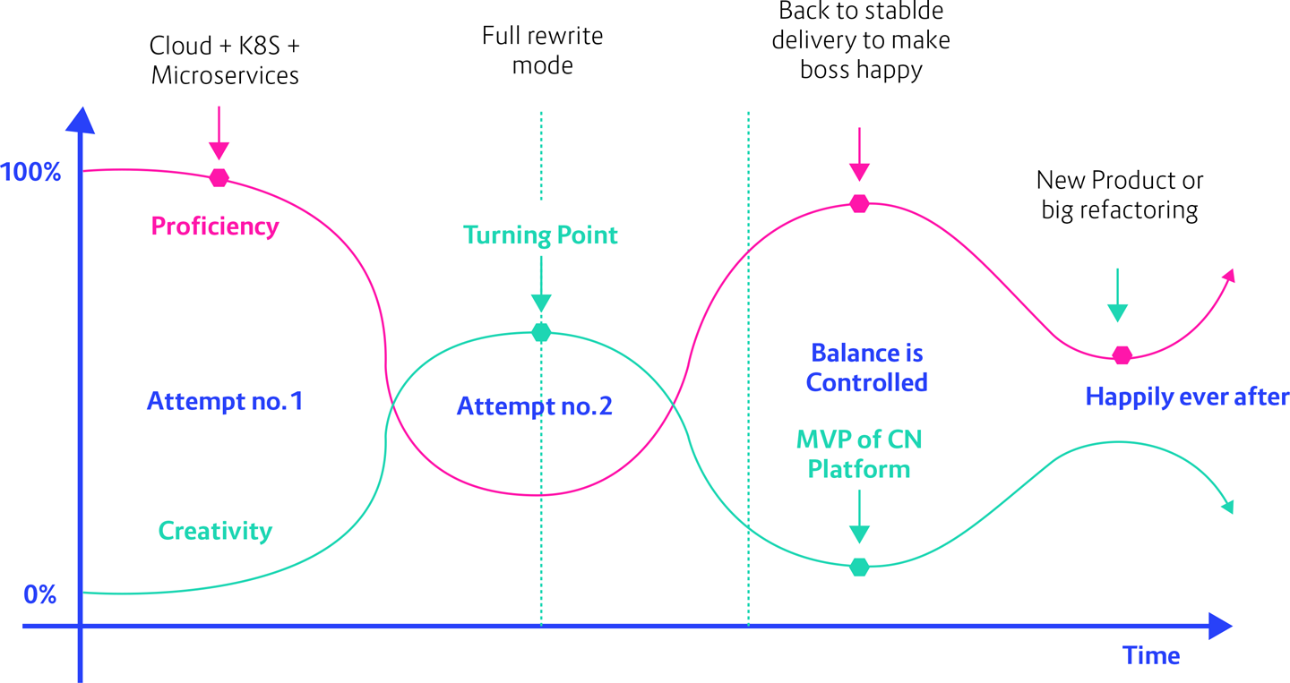

**Figure E-1. The relationship between proficiency and creativity at different points along WealthGrid’s transformation journey**

Attempt number 1 is where WealthGrid does not treat the transformation as a full initiative and remains in primarily proficient mode while Jenny’s small team tries to implement a new cloud native platform as a side project while also still responsible for their regular tasks. Proficiency is very high, and creativity almost zero.

This didn’t work, so the company tried to swing the other way. There was Executive Commitment this time: a big budget allocated and most of the people moved to work on the initiative. Unfortunately, they were still using proficient management and Waterfall team structure—and still treating the transformation as a normal project that is supposed to have predictable results. Thus, the process and the culture did not change to match the new tech. Meanwhile there was so much investment in the new platform that the current platform—the one still in production and delivering the business value to the customers, not to mention earning money—was almost ignored. As a result, the numbers were out of whack again. They were working at perhaps 10 percent investment in delivery, while most of the rest of the company was experimenting all over the place. They were being creative, but in a very disorganized way that generated more problems than it solved.

Once WealthGrid finally stepped back, reassessed, and then came back for their third try, they had a much more balanced approach. By using a Dynamic Strategy, Gradually Raising the Stakes, and in general evolving their processes, management, and culture to be appropriately cloud native they were finally set up for success. A small portion of the engineers formed the Core Team and Platform Team to uncover and then build an MVP version of the new cloud native platform, so creativity swung back to an effective but reasonable level while the remaining team members kept building the functionality customers needed.

At the end, with the new platform in place and all teams onboarded, WealthGrid could rebalance again for optimal efficiency: 80/15/5. Most of the focus (80 percent) returns to delivery, using the Manage for Proficiency approach with the majority of teams to efficiently deliver core business value. However, some teams remain in innovation mode, where Manage for Creativity keeps them effective at innovation—incorporating new tools and methods to significantly improve existing products—while a small percentage does continual research. Research means checking out new technologies that may or may not pan out, but it’s important to understand how they work. Some of these may be useful in a year or two when they become more stable and/or more relevant for the business.

This is how WealthGrid handled things, but it works the same way for everyone. This balance is under your control. You can play with it as needed. You can decide to invest in a big refactoring or to build a new product and pull people into that project for the duration, temporarily placing a significant portion of your team on more creative and innovative tasks. During that time these people need to be managed in a different way, with more open-ended autonomy to create new things. Eventually, however, the problem is solved or the change is achieved, and things rebalance once more toward an emphasis on stable and efficient delivery. Until the next time.

**Jedi Powers Unlocked**

Ultimately this book, all these patterns, were never intended to teach you how to do a cloud native transformation (though it is certainly a helpful byproduct). We wrote this book to help you become comfortable with transformation as a process, so you can move forth confidently as an adaptive, responsive, aware organization ready for any stranger that comes your way.

You have now unlocked your power to deal with uncertainty—*any* uncertainty. That is the essential Jedi mind trick necessary for surviving and thriving in these ever-changing times. In the early days of software development, and up until very recently, everything was very segregated and competition was basically limited by geography. Now everything is fast and global: you are no longer competing only with your neighbors. You are competing with the world. To put it in disruptive stranger-danger terms, in the past you might encounter one stranger in your town every five to ten years. Now, you meet ten on the street every day.

Fundamentally, then, cloud native is *not* about speed, scale, or margin (though these are all terrific side benefits!). Yes, you can now vary your company’s products or services in a cloud native pipeline with the same ease and speed you might update your website using a content management system. The point is not the speed itself, though, but your ability to move at that speed. *Cloud native is about building an organization that can transform and adapt far faster by removing the technical risks associated with change.* With the tools we have outlined throughout this book, using these strategies and methods and patterns, you can handle any change that comes.

At its best, a cloud native approach is as much about de-risking as it is about accelerating change, allowing companies to become more responsive. It’s extremely powerful, yes—but unfortunately “low risk” does not mean “low effort.” Now that you know what you are doing, you still need to do the work. After reading this book you know how to structure your transformation, but you still have to go through a year or two of actually doing it. We can give you the knowledge and tools, but we can’t save you the journey.

The transformation process isn’t free, and it isn’t easy. But what we can tell you is that it’s imperative, in an existential threat sort of way, and absolutely worth it.

And the risk of undertaking it has never been lower.